

Employee Absenteeism

Analysis and Model Generation in Python and R



May 20, 2019

k Venkata charan

Table of Contents

1. Introduction 2

1.1.Problem Statement 2

2. Data Pre-processing 2

2.1 Data 2

2.2. Data Size and Structure: 3

2.3. Completeness of data: 4

2.4.Outlier Analysis 5

2.5. Correlation Plot 7

2.6. Feature Importance Ranking: 9

3. Exploring some of the most important variables 10

3.1. Univariate Analysis based on number of absent hours on a new day 10

3.2. Bivariate Analysis with Absenteeism time 12

3.3. Grouping the variables based on total absenteeism time 13

3.4.2.Measures that company can implement: 16

4. Model Generation 18

4.1. Trend and Seasonality Rolling Mean 18

4.2. Stationarity 20

**4.3.1 Forecasting in R using TSLM** 22

**4.3.2. Forecasting in Python using Linear Regression with manually forecasted Trend Forecasted Values:** 23

**4.3.3. Residuals** 24

4.4. Auto Regressive Integrated Moving Average (ARIMA) 24

**4.4.1. ACF And PACF Plot** 25

**4.4.2. Forecasting** 27

**4.4.3. Residuals Check** 28

4.5. ETS (Exponential Smoothing) 28

**4.5.1. Forecasting** 29

**4.5.2. Residuals** 30

5. Accuracy of three models 30

6. Reference s 31

# **1. Introduction**

## **1.1.Problem Statement**

XYZ is a courier company. As we appreciate that human capital plays an important role in collection, transportation and delivery. The company is passing through genuine issue of Absenteeism. The company has shared it dataset and requested to have an answer on the following areas:

1. What changes company should bring to reduce the number of absenteeism?  
2. How much losses every month can we project in 2011 if same trend of absenteeism continues?

# **2. Data Pre-processing**

## **2.1 Data**

There are 21 variables in our data in which 20 are independent variables and 1 (Absenteeism time in hours) is dependent variable.

Variables Information:

1. Individual identification (ID)

2. Reason for absence (ICD) -

Absences attested by the International Code of Diseases (ICD) stratified into 21 categories (I to XXI) as follows:

I. Certain infectious and parasitic diseases

II. Neoplasms

III. Diseases of the blood and blood-forming organs and certain disorders involving the immune mechanism

IV. Endocrine, nutritional and metabolic diseases

V. Mental and behavioural disorders

VI. Diseases of the nervous system

VII. Diseases of the eye and adnexa

VIII. Diseases of the ear and mastoid process

IX. Diseases of the circulatory system

X. Diseases of the respiratory system

XI. Diseases of the digestive system

XII. Diseases of the skin and subcutaneous tissue

XIII. Diseases of the musculoskeletal system and connective tissue

XIV. Diseases of the genitourinary system

XV. Pregnancy, childbirth and the puerperium

XVI. Certain conditions originating in the perinatal period

XVII. Congenital malformations, deformations and chromosomal abnormalities

XVIII. Symptoms, signs and abnormal clinical and laboratory findings, not elsewhere classified

XIX. Injury, poisoning and certain other consequences of external causes

XX. External causes of morbidity and mortality

XXI. Factors influencing health status and contact with health services

And 7 categories without (CID) patient follow-up (22), medical consultation (23), blood donation (24), laboratory examination (25), unjustified absence (26), physiotherapy (27), dental consultation (28).

3. Month of absence

4. Day of the week (Monday (2), Tuesday (3), Wednesday (4), Thursday (5), Friday (6))

5. Seasons (summer (1), autumn (2), winter (3), spring (4))

6. Transportation expense

7. Distance from Residence to Work (kilometres)

8. Service time

9. Age

10. Work load Average/day

11. Hit target

12. Disciplinary failure (yes=1; no=0)

13. Education (high school (1), graduate (2), postgraduate (3), master and doctor (4))

14. Son (number of children)

15. Social drinker (yes=1; no=0)

16. Social smoker (yes=1; no=0)

17. Pet (number of pet)

18. Weight

19. Height

20. Body mass index

21. Absenteeism time in hours (target)

## **2.2. Data Size and Structure:**

Size: 740 obs. of 21 variables:

Raw Structure:

|  |  |
| --- | --- |
| **VARIABLES** | **DATA TYPE** |
| ID | num 1136371131020141... |
| Reason.for.absence | num 260237232322231922... |
| Month.of.absence | num 7777777777... |
| Day.of.the.week | num 3345566622... |
| Seasons | num 1111111111... |
| Transportation.expense | num 289 118 179 279 289 179 NA 260 155 |
| Distance.from.Residence.to.Work | num 3613515365152501211... |
| Service.time | num 1318181413183111414... |
| Age | num 33503839333828363437... |
| Work.load.Average.day. | num 239554 239554 239554 239554 239554 .. |
| Hit.target | num 97979797979797979797... |
| Disciplinary.failure | num 0100000000... |
| Education | num 1111111113... |
| Son | num 2102201421... |
| Social.drinker | num 1111111110... |
| Social.smoker | num 0001000000... |
| Pet | num 1000104001... |
| Weight | num 90988968908980659588... |
| Height | num 172 178 170 168 172 170 172 168 196 |
| Body.mass.index | num 30313124303127232529... |
| Absenteeism.time.in.hours | num 40242NA84408... |

## **2.3. Completeness of data:**

|  |  |
| --- | --- |
| ***VARIABLES*** | page4image25488544  ***MISSING COUNT*** |
| ID | 0  page4image6875648 |
| Reason.for.absence | 3 |
| Month.of.absence | 0 |
| Year | page4image6877184  0 |
| Day.of.the.week | 0 |
| Seasons | page4image7319552  0 |
| Transportation.expense | 7 |
| Distance.from.Residence.to.Work | 3 |
| Service.time | 3 |
| Age | 3 |
| Work.load.Average.day. | 10 |
| Hit.target | 6 |
| Disciplinary.failure | 6 |
| Education | 10 |
| Son | 6 |
| Social.drinker | 3 |
| Social.smoker | 4 |
| Pet | 2 |
| Weight | 1 |
| Height | 14 |
| Body.mass.index | 31 |
| Absenteeism.time.in.hours | 22 |

## **2.4.Outlier Analysis**

By looking at the below probability distribution we can clearly see that the most of the variables are skewed. The skew in the distribution can be most likely explained by the presence of outliers in the data. Let’s plot a box to check this.

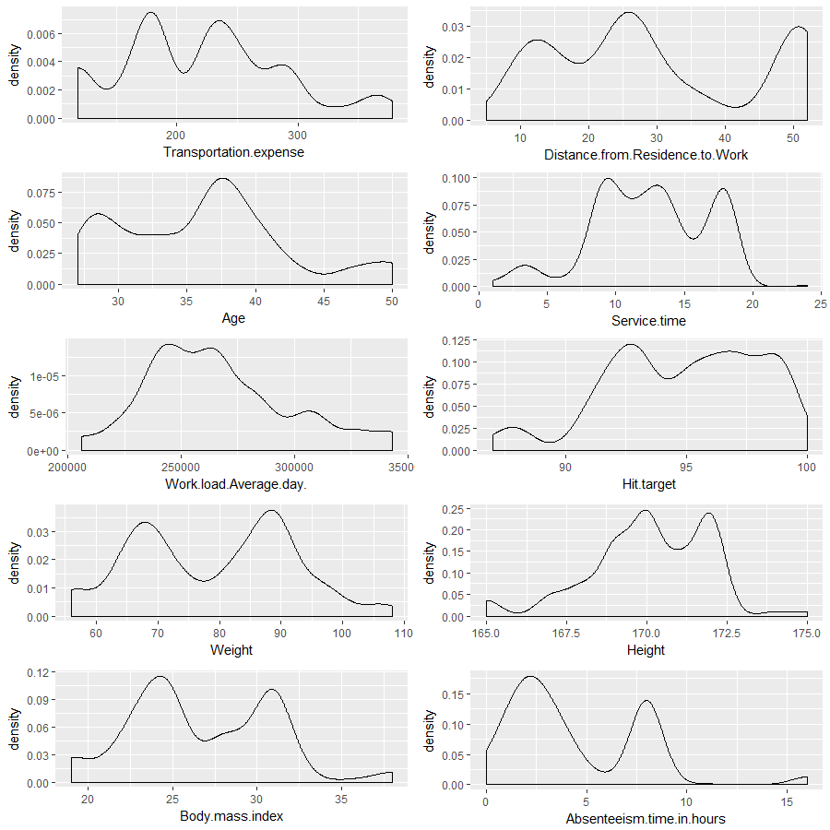

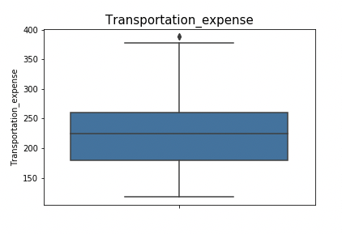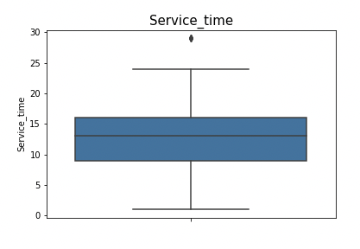

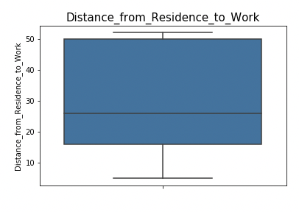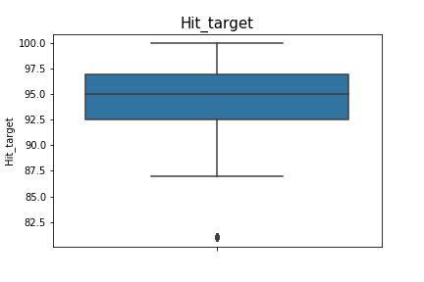

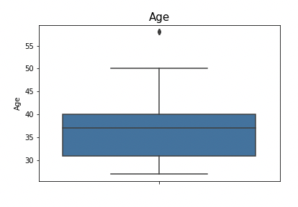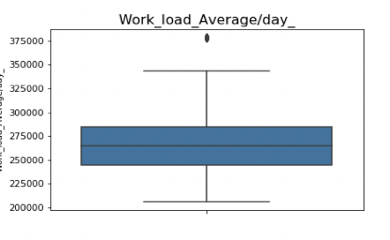

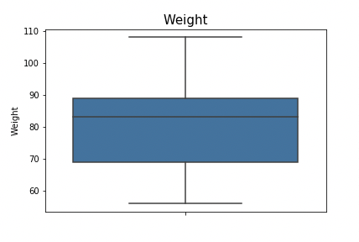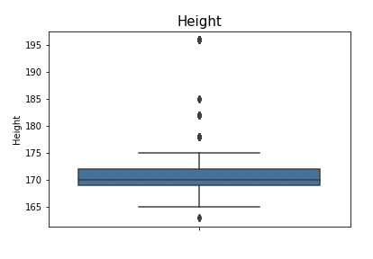

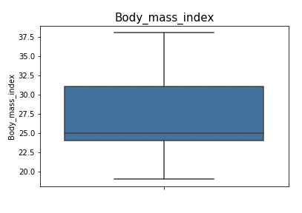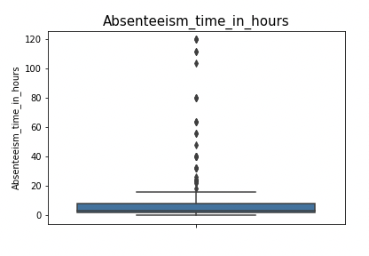

There seems to be many outlier in our target variable Absenteeism_time_in_hours. There are value of 120, 100, 80, 60 which is not possible.

Reason: The data set is a daily data set with no of absent hour per day. A day has max 24 hours, so all these values seems redundant and we need to eliminate these out. Logically the absenteeism hours should be less than the service time of that employee. We will use KNN imputation to impute these outliers.

## **2.5. Correlation Plot**

Before performing any type of modeling we need to assess the importance of each predictor variable in our analysis. There is a possibility that many variables in our analysis are not important at all to the problem of class prediction. We cannot use all the features because some features may be carrying the same information or irrelevant information which can increase overhead. To reduce overhead we adopt feature selection technique to extract meaningful features out of data. This in turn helps us to avoid the problem of multi collinearity. In this project we have selected Correlation Analysis for numerical variable and ANOVA (Analysis of variance) for categorical variable.

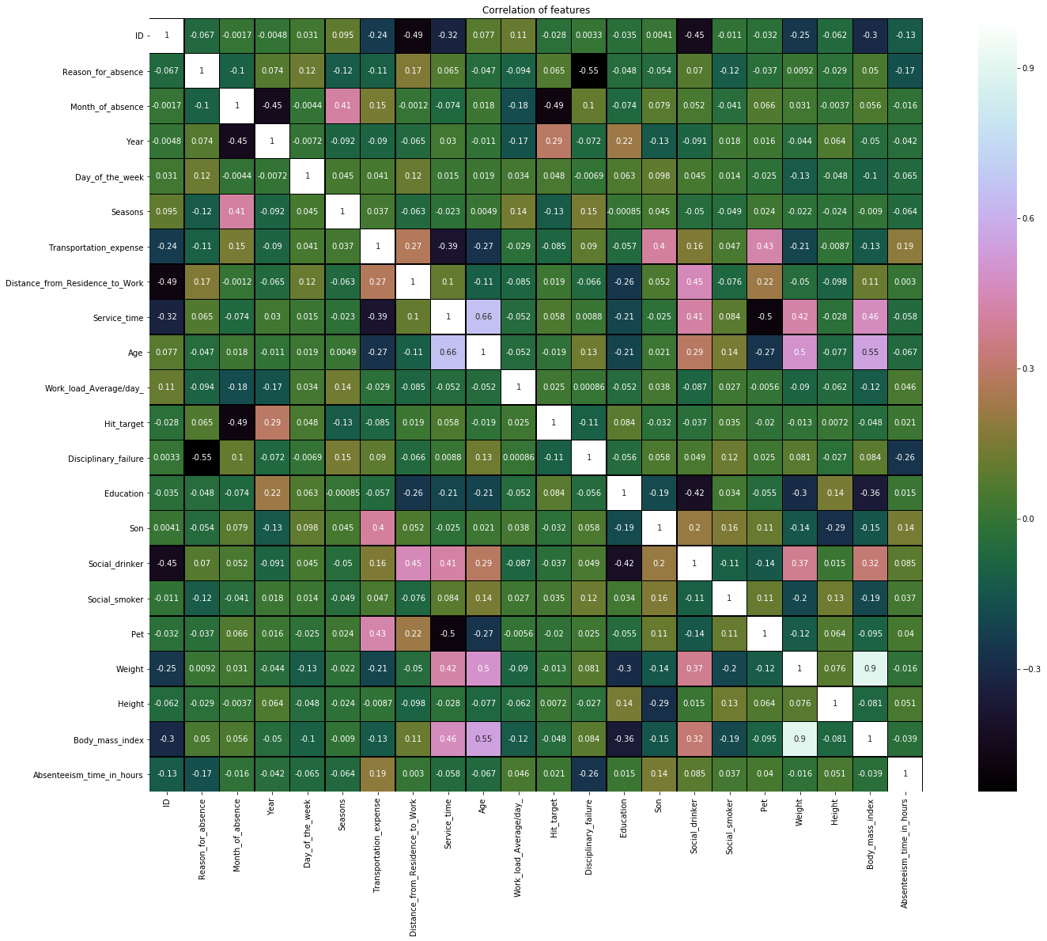

## **2.6. Feature Importance Ranking:**

Selecting subset of relevant columns for the model construction is known as Feature Selection.

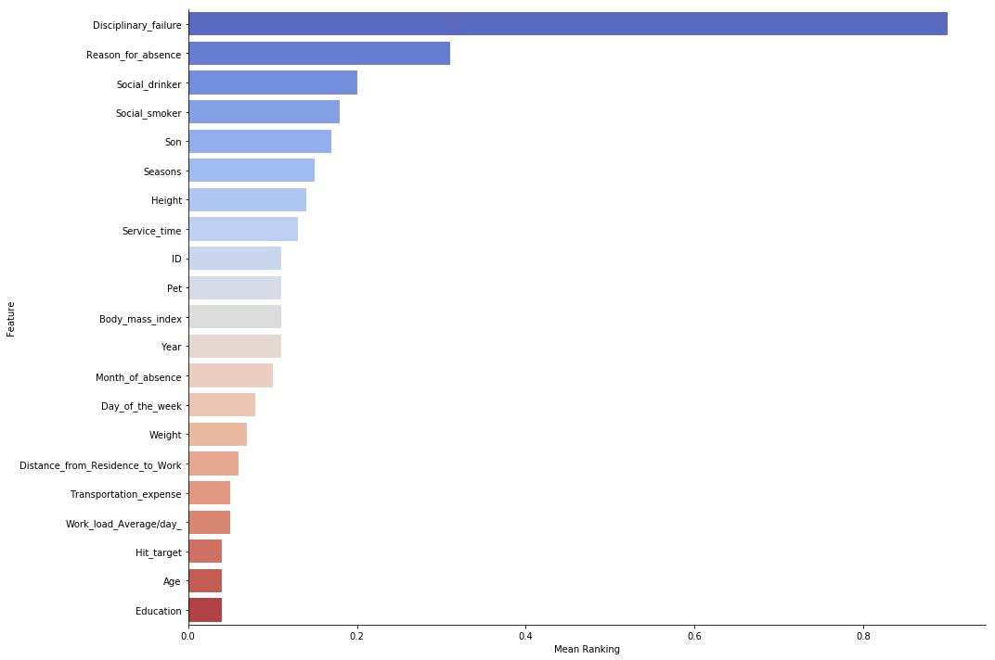

# **3. Exploring some of the most important variables**

## **3.1. Univariate Analysis based on number of absent hours on a new day**

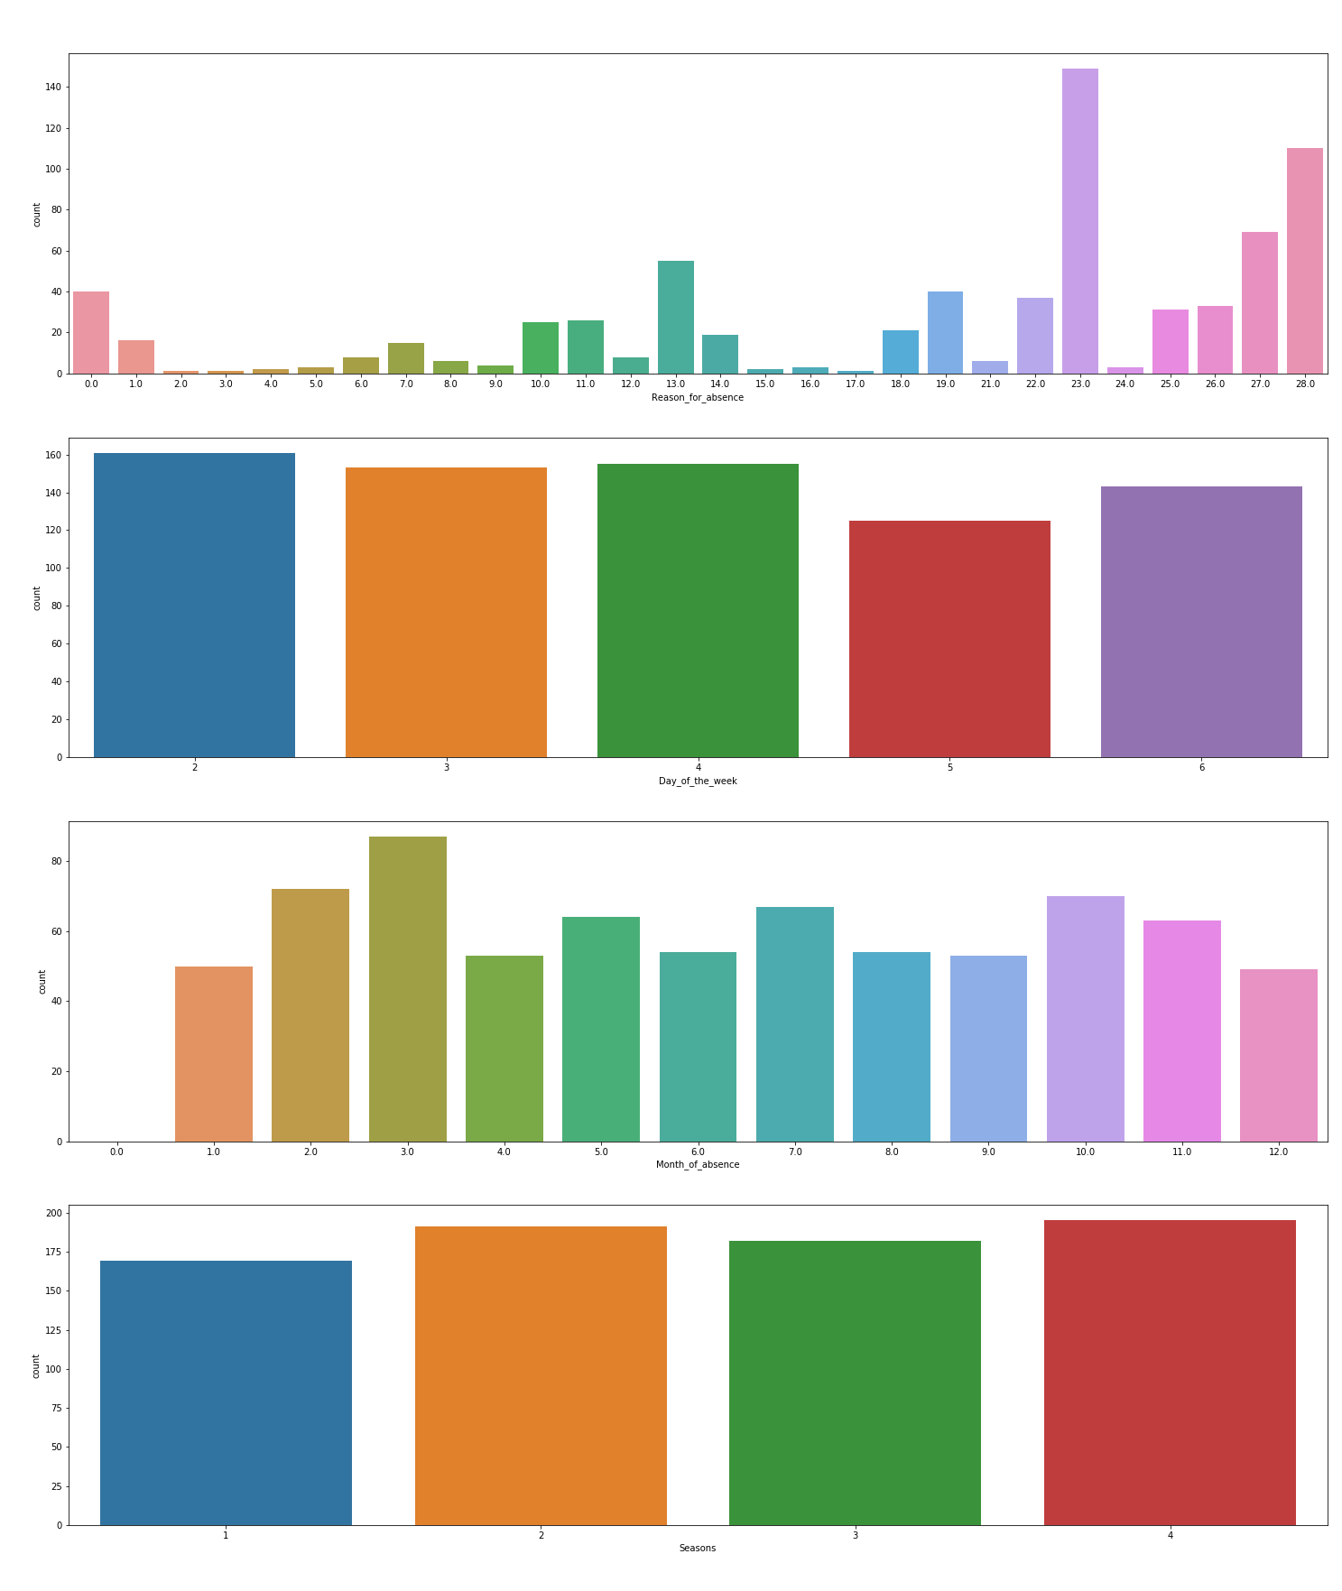

**Quick Observation:**

The above count plots are based on the employee count. There doesn’t seem to be of a much difference in the employee absenteeism hours based on **new day**, month and season. There is no specific day or month or season where the employees are absent. It is distributed uniformly.

But there is something we can see in “reason of absence” plot, the reason of absence on a new day seems to be max for 23 followed by 28, 27, and 13 and so on. (Descending order)

23: Medical Consultation. 28: Dental consultation 27: Physiotherapy 13: Disease of musculoskeletal system and connective tissue.

The point to be noted here is the reason of absence from 1 to 21 are absences attested by the International code of diseases. Reason of absence for 22 to 28 have no attested medical proof.

Out univariate analysis shows that the no attested are the top 3 reason of absence given by the employee on a new day.

## **3.2. Bivariate Analysis with Absenteeism time**

Grouping based on total

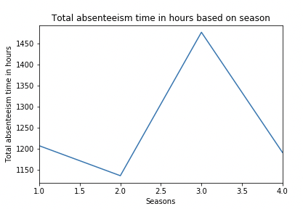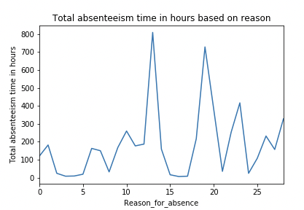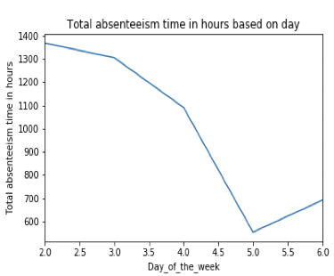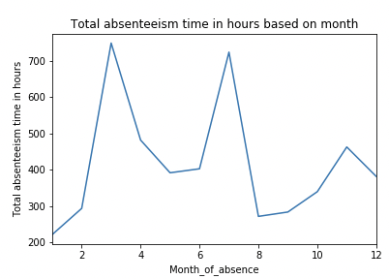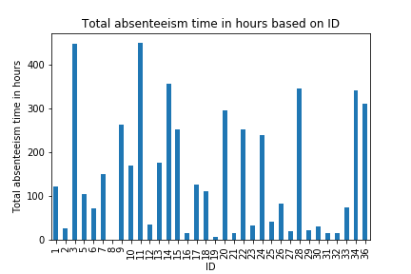

**Quick Insight**:  
Based on Season Plot: We can see that season 3 has the max absentees hours and season 2 lowest but the

difference is not much.

Based on Day Plot: Monday has the highest absentees’ s hours followed by Tuesday and Wednesday. Thursday and Friday being the lowest. The difference here is quite a lot. **Monday has 1390 hours whereas Thursday and Friday has 550 and 700. Looks like people don’t want to go to work on time after a good weekend**.

Based on Month of Absence: March and August sees the highest absentee’s hours.

Based on ID: There are 11 employees with more than 200 hours of absence in 3 years. The highest seems to be above 400 by employee with ID 3.

## **3.3. Grouping the variables based on total absenteeism time**

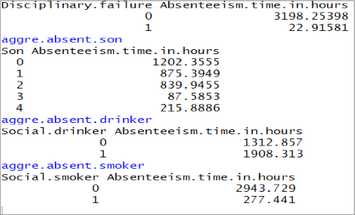

**Below are some suggestions and visualizations that a company should take forward to reduce its rate of absenteeism based on the data provided**

**The Changes which company should bring to reduce the number of absenteeism –**

1. It is observed that employee with low education have maximum absentee time.

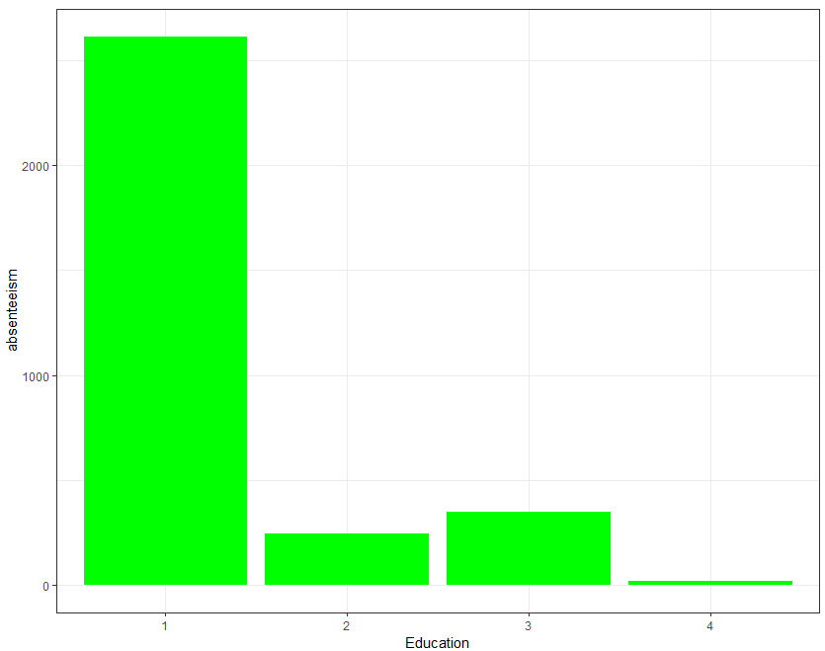

**A firm should hire educated staff as staff with low education is having most absenteeism hours**

1. Some employee with ID 3, 28, 34 are often absent from work, company should take action against them. Or even a warning to them might help

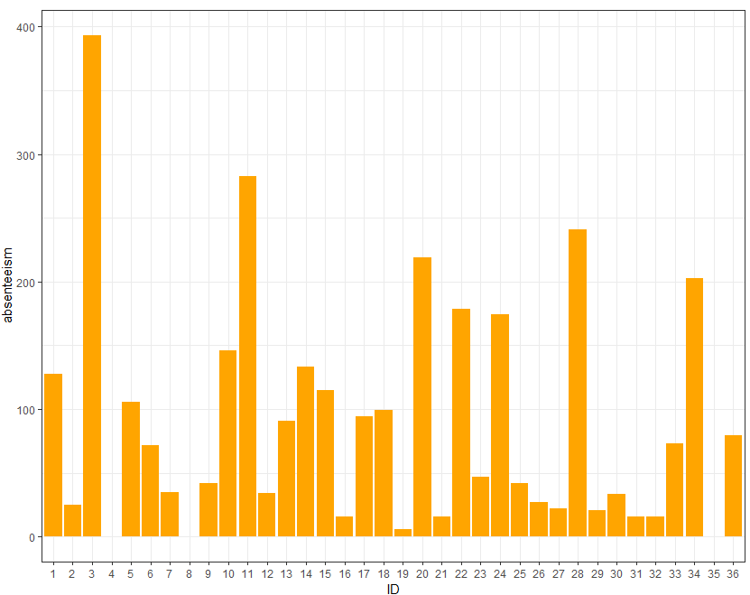

1. Employees who are social smoker have more absentee hour than who are not social smoker.

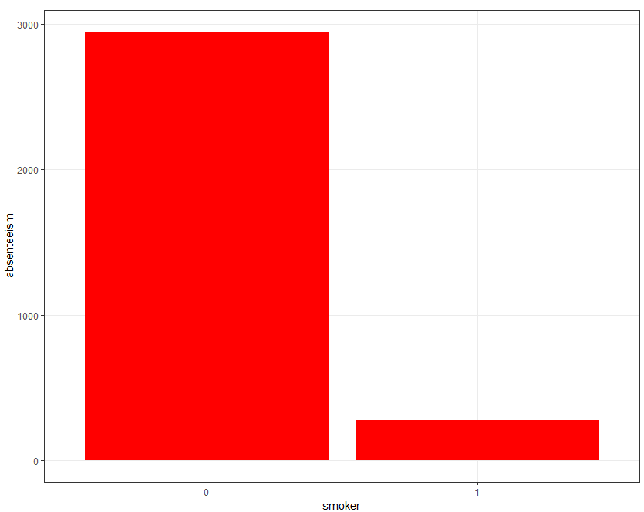

1. As a smoker is more prone to bad health condition so that causes a lot of absenteeism. So a firm should conduct health campaigns to educated employee about the harmful effects of smoking.
2. Most often Reason for absence are medical consultation and dental consultation, company should take care of it. The maximum people taking the absent hours are from category 23 followed by 28 and 27. These category are not attested by doctors. 23: Medical Consultation. 28: Dental consultation 27: Physiotherapy .

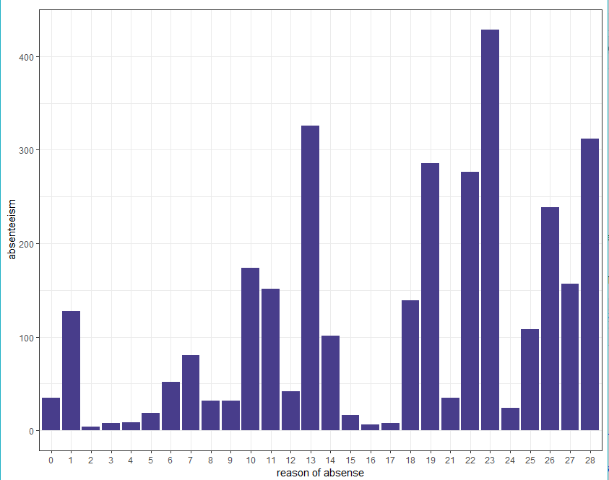

**3.4. Inference  
3.4.1. Current Trend of Absentee’s:**

* The maximum people taking the absent hours are from category 23 followed by 28 and 27. These category are not attested by doctors.

23: Medical Consultation. 28: Dental consultation 27: Physiotherapy

* These reasons seems to be absurd as these are consultation which people might give as an excuse as they don’t have a medical certificate to show.
* Monday, Tuesday and Wednesday have the highest absentees’ hours (In Descending Order), which seems obvious after weekend.
* The employee who doesn’t have any kids seems to be highest in term of total absentee’s hours.
* When there is a disciplinary action, the absentees hours are very low almost negligible. Looks like people become serious once they have been warned for disciplinary issues.

## **3.4.2.Measures that company can implement:**

* As the majority of the reason are consultation, company can organize a free health checkup once in 6 months to keep the track of the medical history of employee. This will also keep a good company environment for the employees and an added perk which can help the company loses in the important business hours.
* As people take disciplinary actions seriously, they can implement a rule where a person being absent for more than 15 hours quarterly will be given a warning. After three warnings employer has the right to fire that employee based on professional ethics.
* As Monday have the highest hours, may be company can extend the service hours for Friday and Thursday and decrease a bit on Monday by opening the office 1 or 2 hours later than usual.
* Company can also introduce a policy where in the Top 5 disciplined employees, holding the least Absentee’s hours will be rewarded. This Reward can be in form of some Reward points that they can redeem later or some gift voucher. This action will encourage employees to strive for excellence in Discipline.
* Should introduce new policy for salary deduction for un-informed or un-approved leaves
* A sandwich leave policy would be a good option to reduce absenteeism on day near to weekends

# **4. Model Generation**

We have grouped the total absentee’s hours based on month of the year, as we need to forecast the total absentee’s hours for 2011.

The line chart shows the total absentee’s hours per month from July 2007 to July 2010.

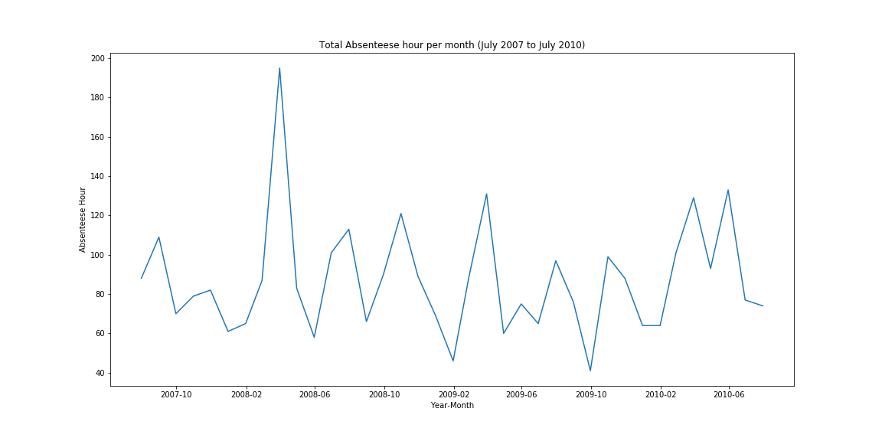

We will build three models for forecasting and will pick the model with better AIC score. We have converted the grouped data based on month of the year into a time series data.

## **4.1. Trend and Seasonality Rolling Mean**

**As we can see in the below plot that our means remains constant with not much variation, there seems to be no trend in the data 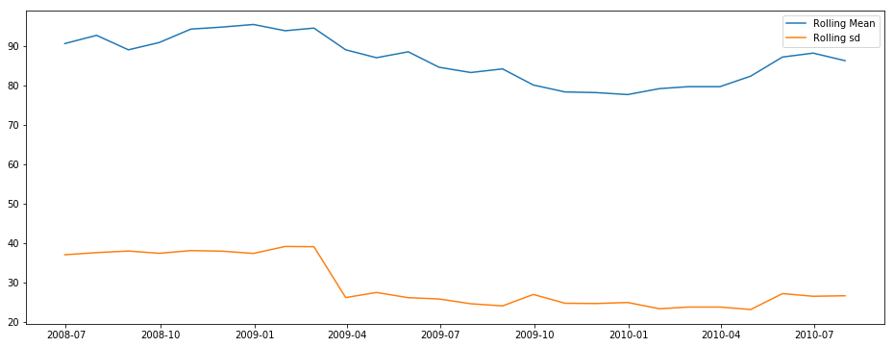.**

**4.1.1. Decomposition**

The below plot shows that there is no trend and seasonality also doesn’t seems to be there. We will confirm the seasonality in our statistical test

**Multiplicative model**

**Additive Model**

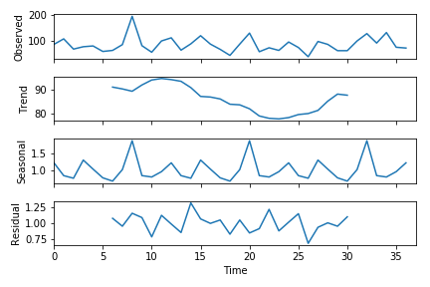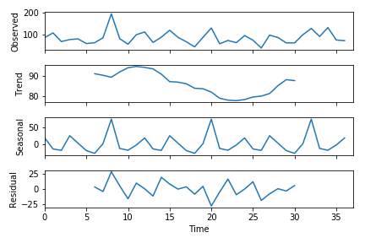

As we can see in rolling mean plot, the mean seems to be constant with time which means there is not much trend in the data i.e. time series seems to be stationary.

In the decomposition plot we can see the trend and seasonality, trend doesn’t seem to be there. The seasonal plot show 3 high peaks in the model. We will confirm about seasonality in are stationarity test.

## **4.2. Stationarity**

We will perform Dicker Full Test to check the stationarity in the dataset. This is one of the statistical tests for checking stationarity. Here the null hypothesis is that the TS is non-stationary. The test results comprise of a Test Statistic and some Critical Values for difference confidence levels. If the ‘Test Statistic’ is less than the ‘Critical Value’, we can reject the null hypothesis and say that the series is stationary

As our p-value is less than 0.05 we can reject our null hypothesis and accept the alternate which says the time series is stationary i.e there is not much trend and seasonality in the data set.

**4.3. Linear Regression with Trend/TSLM  
NOTE**: Model building and forecasting in all the model is done using complete data. Accuracy has been

measured by dividing into train and test  
To forecast using linear regression, I’ve used different linear regression models in R and Python.

**Python**: I’ve used simple linear regression with trend to forecast the values:  
Approach:

* Converted the months into a sequence of number till 37(As we have 37 months data to forecast.
* Calculated the trend series where the value at the current time step is calculated as the difference

between the original observation and the observation at the previous time step.

* Forecasting the trend value till 2011
* Then I’ve build the model using trend and month as predictor and absentees hours as target.
* Forecasted the absentees hours values using the forecasted trend and month variables for the year 2011  
  R: I’ve used time series linear regression with trend to build a model.

**Results of Dickey-Fuller Test:**

**Test Statistic -5.761737e+00**

**p-value 5.651622e-07**

**#Lags Used 1.000000e+00**

**Number of Observations Used 3.500000e+01**

**Critical Value (1%) -3.632743e+00**

**Critical Value (5%) -2.948510e+00**

**Critical Value (10%) -2.613017e+00**

**dtype: float64**

Below is the summary using tslm in R.

|  |
| --- |
| Call: tslm(formula = ts_complete_data ~ trend + season)  Residuals:  Min 1Q Median 3Q Max  -29.2412 -10.2480 0.9058 10.2480 29.2412  Coefficients: Estimate Std. Error t value Pr(>|t|)  (Intercept) 57.3787 14.8215 3.871 0.00123  ** trend -0.1033 season2 33.3466  0.3414 -0.303 0.764771 17.3866 1.918 0.067091 . |
| season3 season4 season5 season6 season7 season8 season9 season10 season11 season12 --- Signif. codes: 0 ‘***’ 0.001 ‘**’ 0.01 ‘*’ 0.05 ‘.’ 0.1 ‘ ’ 1  Residual standard error: 21.29 on 24 degrees of freedom Multiple R-squared: 0.6472, Adjusted R-squared: 0.4708 F-statistic: 3.669 on 12 and 24 DF, p-value: 0.003253  94.7293 21.1265 31.6922 22.7963 35.8854 24.4732 3.1296  17.3967 17.4134 17.4368 17.4669 16.2605 17.4669  5.445 1.35e-05 *** 1.213 0.236848 1.818 0.081641 . 1.305 0.204228 2.207 0.037132 * 1.401 0.173977  40.2377 30.1175 6.3765  17.4368 17.4134 17.3967  0.179 0.859068 2.311 0.029754 * 1.731 0.096250 .  17.3866  0.367 0.717020 |

The estimated trend value is in negative, which means there is no trend. We have observed that in our stationarity test as well. As you can see the adjusted r-square value, we can explain 47% data using time series linear regression.

In python score comes around 54, as we have forecasted trend and then forecasted the absentee hours.

|  |
| --- |
| The Akaike Information Criteria (AIC) is 343.2952. We will use this information to compare the robustne ss of the models.  **Python:** |
| Summary: Estimated intercept coefficient 87.9454542938 Number of coefficients 2 Coefficients Values  AIC of Model: 265.86  Month Trend [0.01493117 0.49195177] |

### **4.3.1 Forecasting in R using TSLM**



Below is the forecast line plot for 2011. Forecasting in all the model is done by training the model on **the complete time series data.**



**Forecasted values**



### **4.3.2. Forecasting in Python using Linear Regression with manually forecasted Trend Forecasted Values:**

|  |  |
| --- | --- |
| Jan 2011 | 87.68970383 |
| Feb 2011 | 87.67519849 |
| March 2011 | page21image6913024  87.66069316 |
| April 2011 | 85.88377786 |
| May 2011 | 85.82916699 |
| June 2011 | 85.77455612 |
| July 2011 | 85.71994525 |
| August 2011 | 85.66533438 |
| September 2011 | 85.61072352 |
| October 2011 | 85.55611265 |
| November 2011 | 85.50150178  page21image6918656 |
| December 2011 | 85.44689091 |

### **4.3.3. Residuals**

We will test the residual as it’s an important measure for the performance of the measure. There should be no pattern in the residuals. As we can see no lag is above the threshold level and the residual seems to be unrelated to each other which is what we wanted. 

## 

## **4.4. Auto Regressive Integrated Moving Average (ARIMA)**

AR: Autoregressive part: Summation of lags, p  
I: Integration, degree of differencing: d  
MA: Moving Average: Summation of forecasting errors, q

### **4.4.1. ACF And PACF Plot**

ACF plot tells about q: Moving average part PACF plot tells about p; auto regression part



ARIMA model there are 3 parameters that are used to help model the major aspects of a times series:



seasonality, trend, and noise. These parameters are labeled **p, d,** and **q.**



The ACF Plot shows two significant lags and PACF Plot show only one significant lag. We can start with ARIMA (1, 0, 1) to start with and then change the parameters and select the one with least AIC score.

We are using auto.arima which will automatically take the best model by comparing the different AIC values at different level of p, d and q.

|  |
| --- |
| Summary:  ARIMA(2,0,2)(1,1,1)[12] ARIMA(0,0,0)(0,1,0)[12] ARIMA(1,0,0)(1,1,0)[12] ARIMA(0,0,1)(0,1,1)[12] ARIMA(0,0,0)(0,1,0)[12] ARIMA(0,0,0)(1,1,0)[12] ARIMA(0,0,0)(0,1,1)[12]  with drift with drift with drift with drift  with drift with drift  : Inf : 243.3661 : 245.8594 : 243.8133  : 241.0087 : 243.6941  : 243.4169 |
| ARIMA(0,0,0)(1,1,1)[12] with drift ARIMA(1,0,0)(0,1,0)[12] with drift ARIMA(0,0,1)(0,1,0)[12] with drift ARIMA(1,0,1)(0,1,0)[12] with drift  **Best model: ARIMA(0,0,0)(0,1,0)**  Series: ts_complete_data ARIMA(0,0,0)(0,1,0)[12]  : Inf : 244.2708 : 243.3077 : 243.4347  sigma^2 estimated as 825.1: log likelihood=-119.42 AIC=240.83 AICc=241.01 BIC=242.05 |

ARIMA (0,0,0)(0,1,0) )[12] , it’s a special case and is known as Seasonal Random Walk. (0, 0, 0) is the non-seasonal part of the model and (0, 1, 0) is the seasonal part of the model. (0, 1, 0) show a seasonal difference.

**A seasonal random walk model is a special case of an ARIMA model in which there is one order of seasonal differencing, a constant term, and no other parameters--i.e., an "ARIMA(0,0,0)x(0,1,0) model with constant.**

As we have a monthly data, whose seasonal period is 12, the seasonal difference at period t is YtYt- 12. Applying the mean model to this series yields the equation:

**Ŷt -Yt-12 =μ**

This forecasting model will be called the seasonal random walk model, because it assumes that each season's values form an independent random walk. For example, the model assumes that September's value this year is a random step away from September's value last year, October's value this year is a random step away from October's value last year, etc., and the mean value of every step is equal to μ:

ŶSep2010 = YSep2009 + μ  
ŶOct2010 = YOct2009 + μ  
The AIC of ARIMA model is better than the Time series model.

### **4.4.2. Forecasting**



**Forecasted values **

### **4.4.3. Residuals Check**

There is no significant lag and the residuals seems to be normally distributed, there is no pattern in the residuals which we wanted.



## **4.5. ETS (Exponential Smoothing)**

As we saw a seasonal parameter ‘D’ in arima model, let’s forecast using ETS model as well as it works best with seasonal parameter even though there is no seasonality in the data. Let’s check what ETS gives.

This model describes the time series with three parameters. *Error - additive, multiplicative(x>0)  
*Trend - non present, additive, multiplicative. *Seasonality - non present, additive, multiplicative.

ETS gives (A, N, N) model which means there is no trend and no seasonality in the data. A means we have an additive error.

### **4.5.1. Forecasting**



**Points Forecasted **

### **4.5.2. Residuals**

**There is one significant lag in the ACF which makes the model weak as compared to the other once we have used.**



# **5. Accuracy of three models**

We divided the time series on train and test 80:20, keeping recent month’s i.e. from Jan 2010 to July 2010 into test and training the model on the previous data. We are using RMSE and MAPE to determine the model performance.

*Linear Regression with trends in python with the manual approach of predicting the trend and forecasting has RMSE 18.5194 and MAPE 19.2891 with AIC value 265.0752*

It is not correct to select the random data for checking the accuracy in time series model. **There was a drastic increase in absentee’s hours in the month of May and a bit in March and April which we have taken into test set. We trained the data which have not seen this pattern and was unable to predict such as high increase which resulted in less RMSE and MAPE value then the Linear Regression with trend using python.**

Seeing the patterns and doing some exhaustive testing on data, ARIMA models looks good with the best AIC score among else.

The best approach if we want to give estimates to the client will be to train the data on the complete set and then predict for next month as there is no seasonality and trend in employees absentees behaviors.



# **6. Reference s**

•  Forecasting principles and practices by Rob J Hyndman

•  Blog article by Ando Sabaas on feature selection